12.56: a) Following the hint, use as the escape velocity 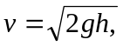 where is the height one can jump from the surface of the earth. Equating this to the expression for the escape speed found in Problem 12.55,
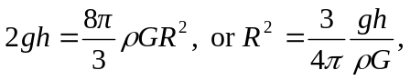
where 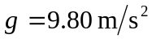 is for the surface of the earth, not the asteroid. Using 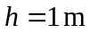(variable for different people, of course), 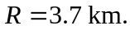 As an alternative, if one’s jump speed is known, the analysis of Problem 12.55 shows that for the same density, the escape speed is proportional to the radius, and one’s jump speed as a fraction of 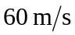 gives the largest radius as a fraction of 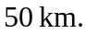 b) With 